**DATABASE ASSIGNMENT: AILENONTOR GODWIN**

**QUESTION1**

create a report that displays the amount spent by each customer on each item displaying date, id of sale and of customer names and amount spent.

use QACS_CH02;

select saledate, saleid, firstname, lastname, total

from sale, customer;

**USING MS SQL:**

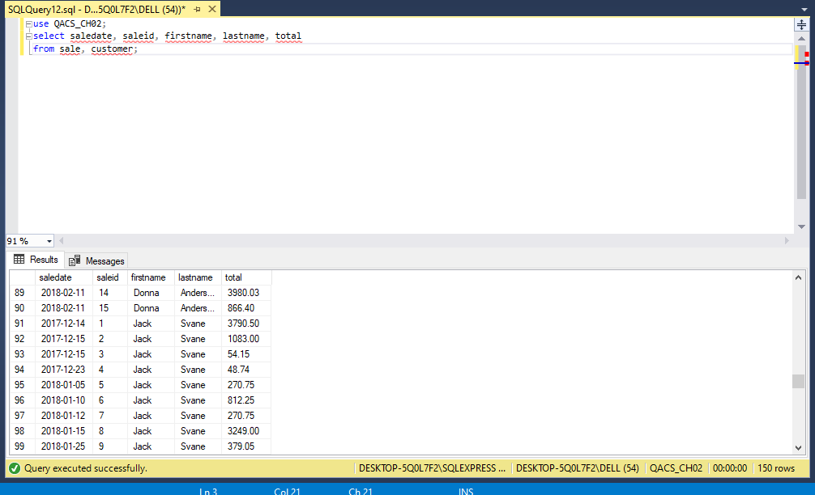

Using workbench:

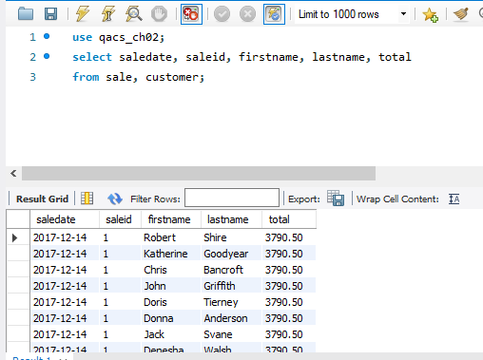

**QUESTION2**: create a report to show the total amount each customer spent in our store, ** customer names, total amount spent alongside id of both customer and sales are needed for the report.

USING MS SQL:

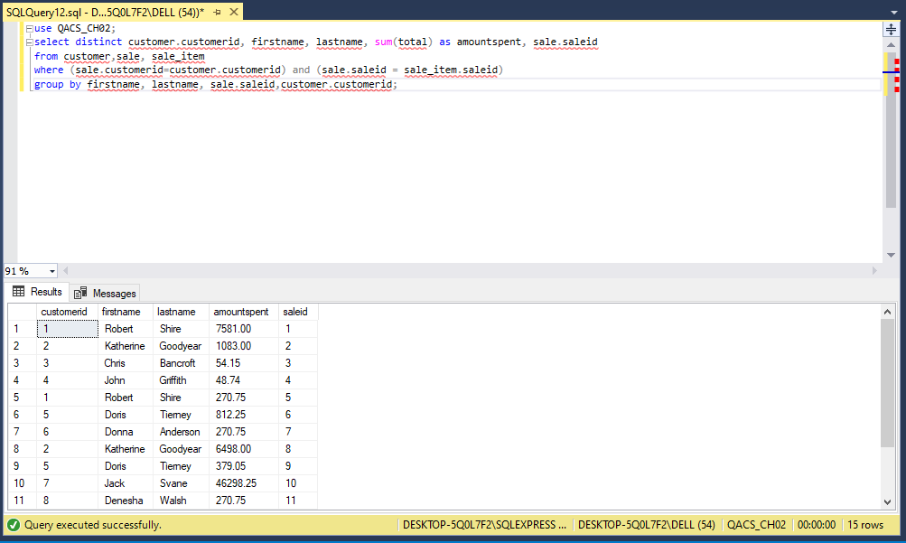

USING WORKBENCH:

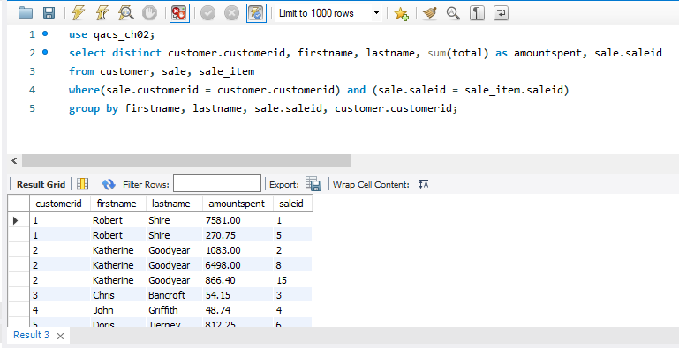

**QUESTION3**: display the total amount we made in the store

USING MS SQL:

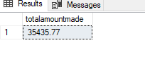

USING WORKBENCH

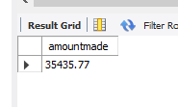

**QUESTION4:** create a report on items in the qac_cho02 database, show item price, sale ItemID ID description and companyname.

Using MSSQL:

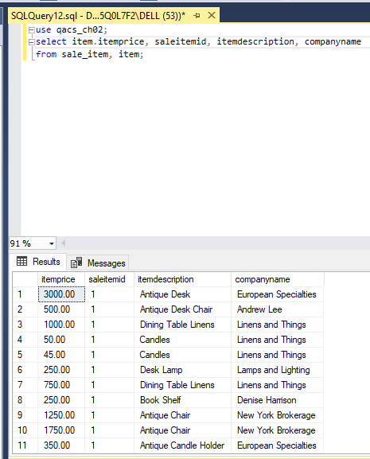

USING WORKBENCH

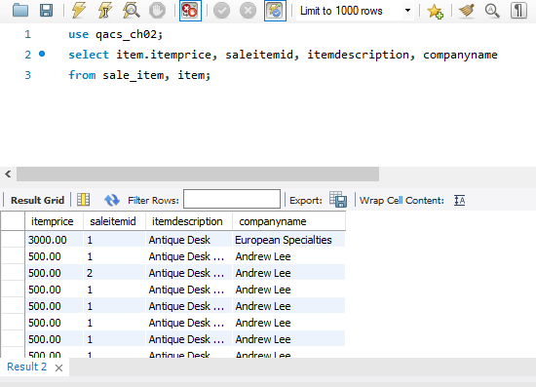

QUESTION5: create a report on items in the qac_cho02 database, display total amount for each sales item id ** show item price, sale Item id item description

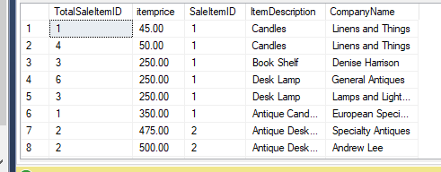

**QUESTION6**: display customer name, item purchased by customer which is an artist work and the amount paid for the work.

USING MSSQL:

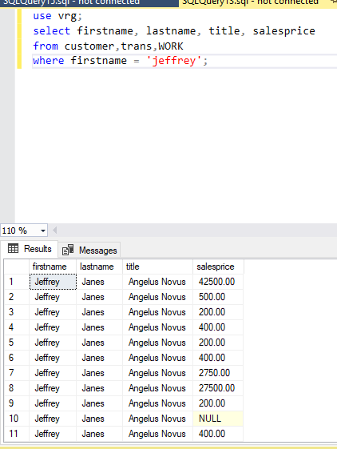

**QUESTION7**: create a report to show the total amount each customer spent in our store **customer names, total amount spent.

